A
Project Report
On

“TRAVELING AGENGY ”

INDEX

SR.NO. TITLE Page No

1. Introduction 1

2. Analysis : - a) Scope of Project 2-4
b) S/W requirement specification
c) H/W & S/W Requirements

- System design :- 5-19
a) Project Description
b) Data flow diagram
c) Module specification

4. Advantages & Disadvantages 20

5. Future Enhancement 21
6. Conclusion 22

7. References 23

INTRODUCTION

Now a day every traveling agency manager has need to maintaining customer details. For this purpose, need the software which could easily and conveniently maintain the customer details.
The record of customer can be stored in the single file. This software can be used in several traveling agencies for keeping the records of the customer and also used to add record of school trip, government officer Holiday, family trip and large industries traveling record.
This project “traveling agency” includes some facilities of travel such as registration, search, display, modification, delete etc. This software searches the client data which is store in the record.
The software used for arranging travel services, provide new and improved services, and identify travel related cost savings.

ANALYSIS

a) Scope of project:
- The aim of project is to provide the traveling services to the customers at reasonable rate. Through this project provide the facilities to the customer such as registration, display, search, modify, delete etc.
- Registration of new customer:

In Registration option add the client information such as client name, address, client no, phone no, total cost of travels, date of registration
- Display:

In Display option, read the all client information such as client no, client name, address, phone no and cost.
- Search:

In search option, search the information about particular client ,such as client no client name, phone no, date of registration and cost.
- Modify:

In modify option, update the particular client no, name, address, phone no and cost.
- Delete:

In delete option, delete the record of particular client no, name, address, phone no cost and date of registration.

b) software requirement specification

- Functionality:
The functionality requirment specify which output should be produced from the given input.
In “Traveling agency’’ project , enter the input as all personal data (name, address, phone no, date) & traveling information & give desired output as total cost of traveling.

- Performance:
This part of SRS specifies performance constraints on the software system.
All the requirement relating to the performance characteristics of the system must be clearly specified.

3.Design constraints:
There are number of factors in the client environment that may restrict the choices of designer.

4.External interface :
All possible interactions of the software with client, hardware & other software should be clearly specified.

c) requirements

Hardware requirements:

Minimum requirements of 64 MB RAM.

Software requirements:

Turbo C
C++
Windows XP

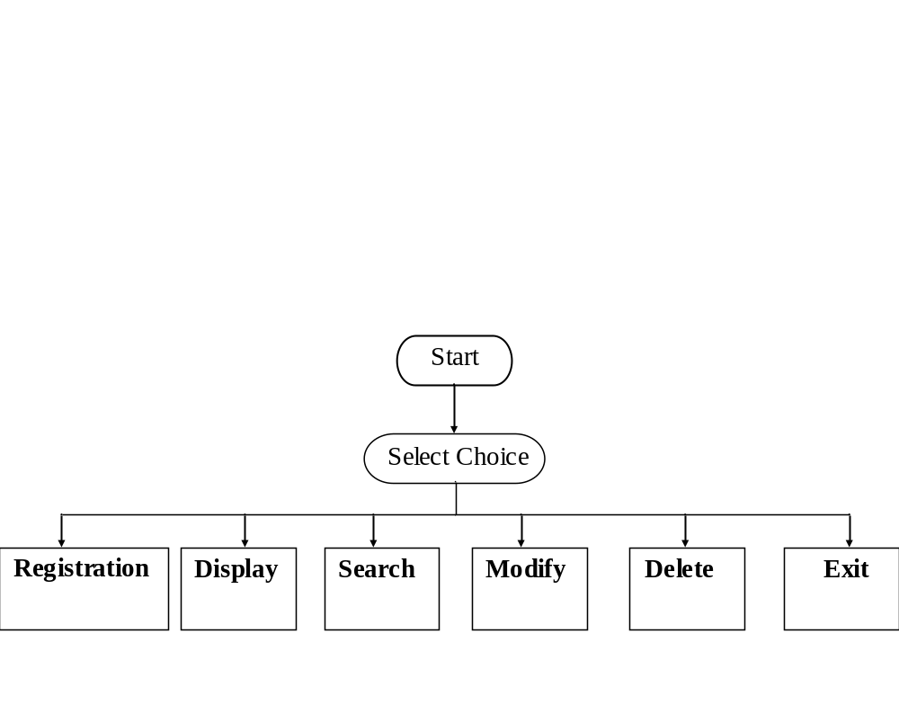SYSTEM DESIGN:

DATA FLOW DIGRAM

Data base

Registration

Display
Personal data
Client

Customer information

Search

client data

Modify

Delete

Enter the
client no

MODULE SPECIFICATION
1.REGISTRATION :
REGISTRATION

PERSONAL
DATA
PLACE
DAYS
SEATS

VEHICLE
BOARD

ONE
DAY
MORE DAY
YELLOW
WHITE

10
6
16
TRAVELS
SUMO
INDICA

CLIENT
NO
CLIENT
NAME
CLIENT PHONE NO
CLIENT ADDRESS
REGISTRATION
DATE

In Registration option add the client information such as client name, address, client no, phone no, total cost of travels, date of registration .
Following calculations are carried out to calculate the total cost of travels:
1) travels of yellow board :
Total cost of travels=((per km+Temporary pervana(TP))*(total km))
2) travels of white board:
Total cost of travels =(per km*total km)

2.DISPLAY
DISPLAY
DATA

CLIENT
NO
CLIENT
NAME
CLIENT ADDRESS
CLIENT
PHONE
NO
REGISTRATION
DATE
COST

EXIT

In display option, read the all client information such as client no ,client name, address, phone no and cost and date of Registration.

- SEARCH
SEARCH
DATA

ENTER
CLIENT NO

IF
CLIENT NO
IS PRESENT

no

yes
DISPLAY
DATA

EXIT

In search option, search the information about particular client such as client no
Client name, phone no, date of registration and total cost.

4.MODIFY
MODIFY
DATA

ENTER
CLIENT NO

IF
CLIENT NO
IS PRESENT
no

yes
Modify client information

CLIENT
NAME
CLIENT ADDRESS
CLIENT
PHONE
NO.
COST

EXIT

In modification option, update the particular name, address, phone no and cost.

5. dELETE
DELETE
DATA

ENTER
CLIENT NO

IF
CLIENT NO
IS PRESENT

yes no

yes
DELETE
DATA OF
CLIENT

EXIT

In delete option, delete the record of particular client no, name, address, phone no, cost and date of Registration.

out put of program
1)REGISTRATION.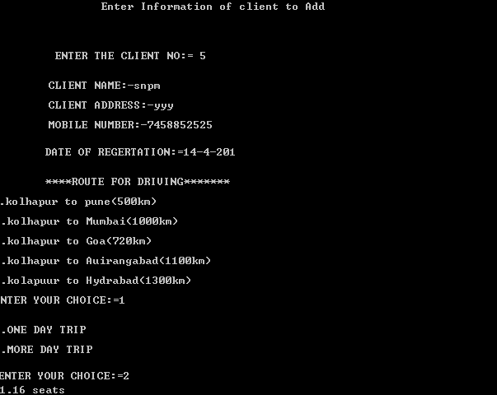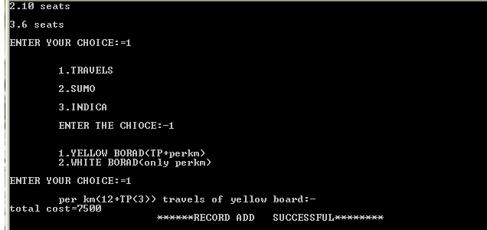

2.DISPLAY

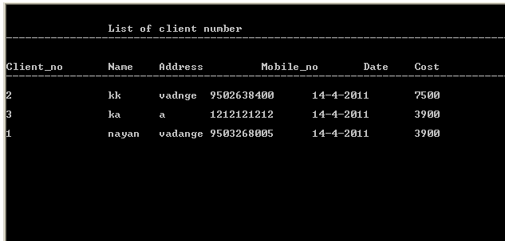

3.SERACH

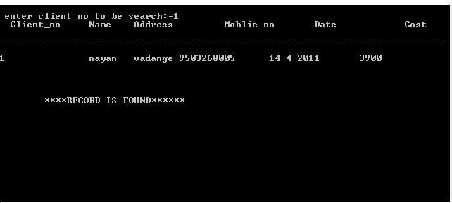
4.MODIFY

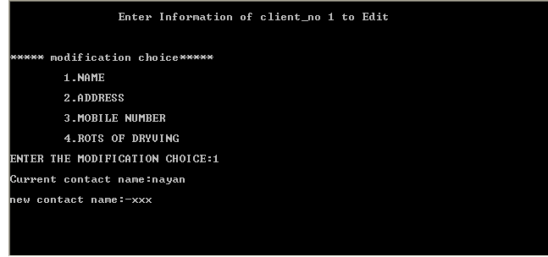

5.DELETE

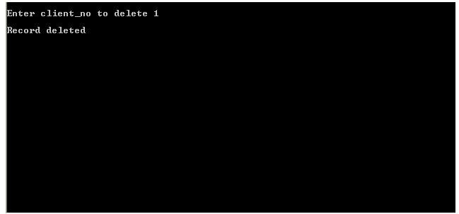

Header FILEs are used

There are the following library functions which are used in this program. The uses of these functions are also given below:

1.#include<iostream.h>
This header file contains all the standard input and output functions.

cin>>=It is used for scan the data. This is same as scanf function .

cout<<=It is used for print the data.This is same as printf function .

2.#include<conio.h>
This header file contains console input output functions.
e.g.
- getch(): it gets the character from the console. It reads a single character directly from the keyboard, without echoing it on the screen.
- void main():-When used as a function return type, void means that the function does not return a value.
- gotoxy():- It moves the cursor to the given position in the current text window. If the coordinates are invalid, the call gotoxy() is ignored.
- clrscr():-It clears the current text window and place the cursor in the upper left hand corner.
3.#include<process .h>
- exit():-It terminates the calling process. Before termination exit does the following:
1. close all files.
2. Writes buffered output.(waiting to be output)
3. call any registered”exit function”.

4.#include<string .h>
This header file contains function prototypes for c-style string processing functions.
- Constant, data type and global variable are used for some comparisons of character, check length for character.

5.#include<ctype.h>
This header file contains function prototypes for functions that test characters for
certain properties, and function prototypes for functions that can be used to convert lowercase letters to uppercase letters and vice versa.
- This header file is used for validation such as name validation,phone validation etc.

6.#include<dos.h>
- Include the date in project using dos header file.
Data d;
7.#include<fstream.h>
This header file contains function prototypes for functions that perform input from files on disk and output to files on disk.
8.#include<stdio.h>
This header file contains function prototypes for the standarad input/output library functions and information used by them.
9.#include<graphics.h>
This header file contains graphics function.
e.g. outtextxy(), setcolor(), settextstyle().

Graphics used in this project :-

1. setbkcolor(int color);
This function used sets the text color to the back ground.

2. setcolor(int color);
This function used sets the text color to the text.

3.settextstyle (int font, int direction,int charsize);
This function used sets the text font, the direction in which the text is displayed & the size of characters.

4.outtextxy(“int x,int y”);
This function used display a text string in the viewport at the position(x,y).

5.Closegraph();
This function used deallocates all memory allocated by the graphics system.

File handling functionS

File handling :=
Many real-life problem handle large volume of data and ,in such situations, we need to use some devices such as Floppy disk or hard disk to store the data. The data is stored in these devices using the concept of files. A file is a collection of related data stored in a particular area on the disk. Programs can be designed to perform the read and write operations on these files.

Class for file stream operation :=
The I/O system of CPP contain a set of classes that define the file handling methods. This include ifstream,ofstream and fstream. These classes are derived from fstream base and the corresponding iostream class as show in fig. the classes ,designed manage the disk ,are declared in fstream and therefore we must include this file in any program that uses file.

Opening file Syntax:=
File –stream-class stream –object;
Stream –object .open(“filename”,ios::mode);

- Mode for opening the file:-
1)ios::app ->To append at the end of file
2)ios::out->it open file in write only mode.
3) ios::in->it open file in read only mode.
4)ios::trunc->it delete’s contain of file if file is already present .
5) ios::ate->go tom end of file on opening.
6)ios::binary->binary file.
7) ios::nocreate ->if file is does not exit.

Read file syntax:=
Stream –object .read((char*)&class-object,sizeof(class-object));

Write files syntax:=
Stream -object.write((char*)&class-object,sizeof(class -object));

Function for manipulation of file pointer

a)Seekg():=
Move get pointer (input) to a specified location

Syntax :=
Strem-object.seekg(offste,refposition);
e.g .stream-object.seekg(location,ios::beg|ios::end|ios::cur);

b)seekp():=
move put pointer (output) to a specified location.

Syntax :=stream-object.seekp(offset,refposition);

c)tellg() & tellp() :=
To enquire their current position we can use the function iostream::tellg() and ostream::tellp().

- f.close():-
It closes the stream. All buffers associated with the stream are flushed before closing. System allocates buffers are freed upon closing. Buffers are assigned with setbuf are not automatically freed.
Return value:-
On success:-return 0.
On error:-return EOF
Declaration:-f.close(FILE*stream);

Advantages

1) Customer does not have to wait in long queues.

2) Customer does not need to worry about buying tickets and booking hotels.

3) This software reduces paper work.
4) It is easy to handle customer’s record.
5) This software saves the time.
6) Information of the customer stores permanently.

Disadvantages
1) This system suitable for only few places.
2) This system suitable for only three vehicles.
3) Online facility is not available.

Future Enhancement
- Modify this system to perform additional operations such as modification the Registration date
of travels etc.
- This system will be extended in future to handle number of places and also provide facility of more
Vehicles.
- In future the system can be done online

Conclusion

This software is efficient in maintaining customer’s details and can easily perform operations on customer’s records. This software also reduces the work load of the travel agency manager.

In future, this system can launch web site for easy online registration. In this system there is limitation for places and vehicles. In future, it can be extended to add more place and vehicles.

References

Let Us C++
- Yashavant Kanetkar

Object Oriented Programming with C++
- E Balagurusamy

